Press Release

For immediate release

HOW BELFAST

GOT THE BLUES

A Cultural History of Popular Music in the 1960s

Noel McLaughlin & Joanna Braniff
Publication date: October 2020
Publisher: Intellect Books; New edition
Paperback: 550 pages
Price: £29.99

The popular history of Northern Ireland has been overshadowed by the violence of the Troubles. How Belfast Got the Blues offers a corrective, reconsidering the period before 1969 and arguing that popular music in Northern Ireland was central to the politics of the time, in ways not previously understood or explored.
Written in a style accessible to both academics and general readers, How Belfast Got the Blues unearths the city’s largely overlooked and significant role in the broader relationship between popular music and politics in this ‘most mythologized of decades’.

This book offers an engaging and dynamic reconsideration of Belfast’s long-ignored contributions to the popular music and cultural politics of the 1960s.
In an expansive socio-cultural history, the authors explore how popular music engaged with and influenced the global cultural and political currents of the decade.

By intertwining politics, culture, and unexplored key personalities, the authors reexamine this radical decade and the complex but essential relationship between music and identity in a place where it could mean the difference between life and death.

Placing Northern Ireland at the forefront of a key moment in British and Irish cultural history, the authors weave a fascinating account of the popular-musical culture and local ‘scene’ in Northern Ireland with the broader and highly complex context of the social-political milieu, offering original and insightful readings of key 1960s figures, including the early career of Van Morrison and Them, the neglected Belfast blues singer Ottilie Patterson, the provocative film director Peter Whitehead, and The Rolling Stones.

The book also includes new material, obtained in interviews and through meticulous archival research, to challenge the mainstream narrative of the mid-1960s music scene in Belfast.

By intertwining politics, culture and unexplored key personalities, the authors have fashioned a new lens to re-examine this most radical decade and the complex but essential relationship between music and identity.

For more information, please visit www.howbelfastgottheblues.com
To request a review copy contact Georgia Glasspole at Intellect on georgia@intellectbooks.com
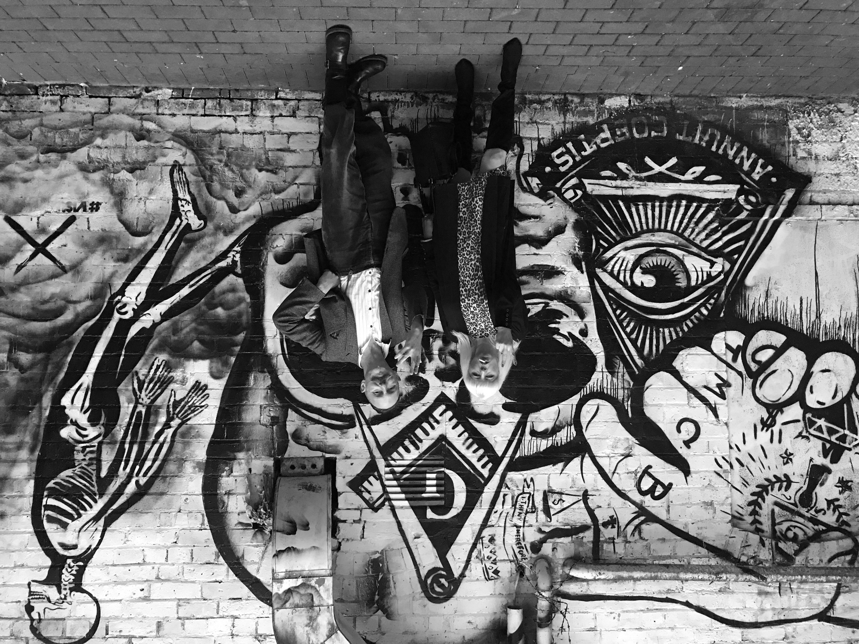
Authors’ Biogs

Dr Noel McLaughlin is Senior Lecturer in Film and Television Studies, Department of Arts, Northumbria University, Newcastle-Upon-Tyne, UK. He has published widely on Irish rock and popular music. His most recent book is Rock and Popular Music in Ireland: Before and After U2 (with Martin McLoone, Irish Academic Press, 2012).
Joanna Braniff is an independent scholar based in Belfast. She was features editor of The Irish News from 2002 to 2008. She was a director of communications for the Green Party in the Northern Ireland Assembly from 2010 to 2015. Joanna now works as a freelance journalist, author and media consultant, specialising in arts and culture. Her interests include environmental and progressive politics.

Reviews
This is an amazing book. It takes existing knowledge on a number of topics – Belfast and the beginnings of the Troubles; popular music culture in Belfast in the 1960s; the general political and cultural context of the UK and Ireland in that decade – and revisits that knowledge with a revisionism that is daring, innovative and certain to be seen as controversial. This is more than just another history of Belfast and Van Morrison.
While popular music remains at the centre of the book’s focus, the concerns about music are woven into a deeper pattern of politics, religion, economics and local, national and international culture. The scale of the achievement is really impressive and by the end, I was dazzled by the breadth and depth of the research.'
Martin McLoone, author of Irish Film: The Emergence of a Contemporary Cinema

‘This important book represents a paradigm shift in Irish popular music studies.
It deftly explores the connections between music and politics, both local and global, national and international, addressing a significant gap in Ireland’s popular music scholarship.’
Michael Mary Murphy, co-author of Local Acts, Global Success: How Ireland Produced Popular Music (with Jim Rogers)

‘Well-researched, accessibly written, fascinating and highly original. This book (re-)places Northern Ireland at the heart of key popular-musical, and broader popular-cultural, moments in the 1960s.
It explores an overlooked and under researched area of British and Irish popular-musical history, presenting new evidence and challenging many existing myths.’
Sean Campbell, author of ‘Irish Blood, English Heart’: Second-Generation Irish Musicians in England

‘This superbly written volume will endure as the definitive guide to the countercultural Belfast music scene in the utopian decade of the 1960s. It is, at once, full of local texture and alive to Belfast’s complex network of connectivity to international musical trends and political forces. A rich and compelling book.’
P. J. Mathews, member of the governing board of RTÉ

For interview requests or further information, please get in touch with:
Press and Media: Jo Campbell T:+44 (0)7808862141 E: jo.writeherewritenow@gmail.com
Sales enquiries: Faith Newcombe E: faith@intellectbooks.com
www.howbelfastgottheblues.com

